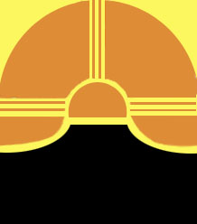
New Mexico Association of Museums
Annual Hewett Awards
Nomination Form 2018

Edgar Lee Hewett was the first director of the Museum of New Mexico from 1909 until his death in 1946. He taught anthropology at UNM and was instrumental in encouraging the development of small museums throughout New Mexico. NMAM bestows two yearly awards in his honor.

Eligibility: The award is made to a person or organization whose actions exemplify leadership or service to the New Mexico museum community. Recipients do not have to be members of NMAM or work in the museum industry to be considered.

Nomination Process: Recipients of the Hewett Award (usually one individual and one organization) are chosen annually by the NMAM board based on nominations from the NMAM membership. Any member of NMAM in good standing can nominate potential recipients.

Recognition: The awards are generally presented to the recipient or accepted on behalf of an organization at the business luncheon during the annual meeting.

Potential Recipient ( Individual or Organization):

Organization:

Address:

City, State, Zip:

Phone:

Email:

Name of Nominator:

Phone:

Email:

Briefly describe why this person or organization should be considered for the Hewett Award:

Please e-mail nominations to:
Adrienne T Boggs, aboggs@fmtn.org

Deadline for nominations is September 14, 2018.

