Nominations for NMAM Board – 2018 Election
Newly elected officers will take office in January, 2018 and serve 2 years. Officers are elected by the general membership and announced at the Annual Business Meeting in November. All Members in good standing are eligible for nomination as officers of the Association. The Board meets monthly either through a teleconference or a meeting at various sites. Nominees should be able to attend the majority of these meetings.
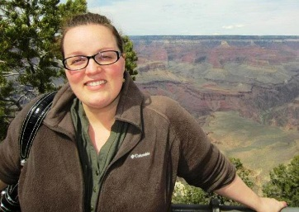
First Vice-President: Adrienne T Boggs, Education Coordinator with the Farmington Museum, has agreed to run for First Vice-President.
Duties: The First Vice-President cooperates with and assists the President in the performance of his/her duties and performs the duties of the President in his/her absence. In the event of a vacancy in the President's office, the First Vice-President assumes this office for the remainder of the unexpired term. The First Vice-President chairs the Nominating Committee and the Scholarship and Awards Committees, and oversees the listserv and website.
Bio: For the past six years Adrienne has managed educational programs and events for the Farmington Museum, as well as serving as Membership Officer and First Vice-President for the New Mexico Association of Museums. Before coming to New Mexico, she worked as a museum educator for the High Desert Museum in Bend, Oregon and the Douglas County Museum of Natural & Cultural History in Roseburg, Oregon. Adrienne earned her MA in Art History/Museum Studies from the University of Denver and her BA in Art History, English, and Music from Lawrence University in Appleton, Wisconsin. She has immensely enjoyed her time serving with NMAM and would appreciate the opportunity to continue serving. Getting to know fellow museum professionals across the state and assisting the organization in furthering its mission of supporting and improving New Mexico museums has been an invaluable experience.
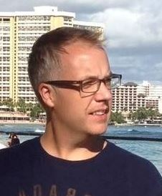
Treasurer: Andy Albertson, Adult Education Manager/Marketing Specialist with the Museum of Indian Arts & Culture, has agreed to run for Treasurer.
Duties: The Treasurer manages the finances of the Association, receives membership dues from the Membership Officer, pays bills, administers grants, submits a financial report to the membership at the Annual Business Meeting, and, upon request of the Executive Committee, submits progress reports, and makes the financial records available for audit. The Treasurer must comply with all state and federal tax return, registration, and reporting deadlines.
Bio: Andy Albertson was drafted in late 2015 to serve a complete two-year term as NMAM Treasurer following the unexpected departure of the recently reelected incumbent. He has managed the “books,” down to the penny, passing 2016’s audit with flying colors. Having worked in museums – mostly in professional education positions – since 1998, it is numbers and budgets that bring him true joy, as he relishes the finite nature of bookkeeping: it’s either right or it’s wrong. He runs the Silent Auction and is passionate about the Scholarship Fund – he will find you, you will donate something, and you will spend for the cause! He had previously served one year as the Northeastern State Representative on the NMAM Board before being whisked into the Treasurer position. By day Andy is the Museum of Indian Arts & Culture’s (MIAC) Adult Education Manager, a role in which he manages volunteer docents, adult tour schedules, and the logistics of planning large events, lectures, film screenings, workshops, demonstrations, etc. What’s left of his time is spent on marketing MIAC through its website, social media, and regional print presence. As of publication, Andy is starting his fourth year at MIAC. Prior to moving to Santa Fe, Andy worked for the City of Las Cruces Museum System, first at its Branigan Cultural Center, and then at the Museum of Art, as Curator of Education. Before moving to NM, Andy was the inaugural curator of education and public programs for a new American art museum in upstate New York, and has worked, interned and/or consulted with at least a dozen other institutions over the last two decades. He serves on AASLH’s National Excellence in History awards committee, representing NM, TX, and OK, and twice served on the annual conference program committee. He is also on AASLH’s national Education & Interpretation Committee. From 2011 – 2016, Andy was Class Co-Chair for the Annual Fund at Vassar College, his beloved alma mater, smashing all previous participation rates and total giving goals in 2015 and 2016, respectively. His BA is in American Culture, which he parlayed into an MA in History Museum Studies from the Cooperstown Graduate Program; he assists with its annual online silent auction, which broken the $10K mark last year. A frequent IMLS grant reviewer, and “Public Dimension” MAP Reviewer for AAM, Andy is committed to a life of service in museums (hell – he’s more than halfway there!) and is strongly considering pursuit of an MBA to eventually transition into museum finance, maybe. Oh, he also tends to be quite verbose.

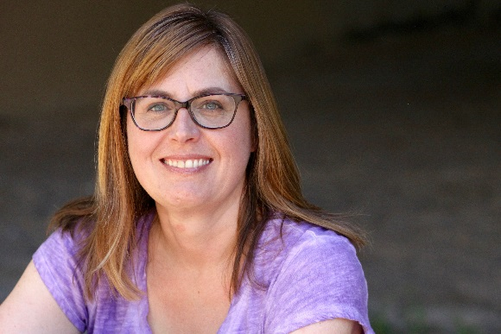
Membership Officer: Emily Stovel, Site Manager with Casa San Ysidro, Albuquerque Museum, has agreed to run for Membership Officer.
Duties: The Membership Officer is responsible for maintaining membership records and soliciting new members for the Association.
Bio: Although Emily was born in Canada, as an academic for 20 years, she conducted research in Chile, Bolivia, Argentina, and Peru. She focused on South American archaeology, identity studies, and community outreach. Recently Emily served as a member of the executive committee and director of the graduate program at the Insituto de Investigación Arqueológica y Museo Gustavo Le Paige in San Pedro de Atacama, Chile (http://iaa.ucn.cl/web/) and built a Museum Studies program at Ripon College (http://www.ripon.edu/). After serving as tour coordinator at Casa San Ysidro: the Gutiérrez/Minge House in Corrales New Mexico, she is honored to work as the Site Manager in order to further reinforce and extend the Albuquerque Museum’s strong commitment to community engagement by expanding visitation, docent participation, partnerships, and site use opportunities at their extension facility in Sandoval County.

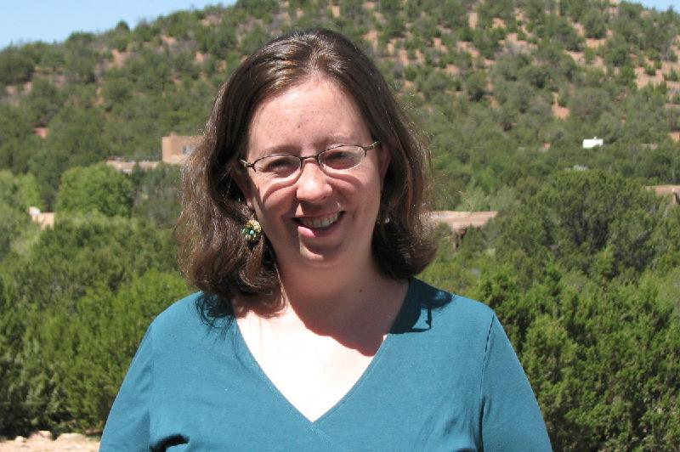
Mountain-Plains Museums Association Representative: Mollie Parsons, Education Director with the Santa Fe Botanical Garden, has agreed to run for MPMA Representative.
Duties: The Mountain-Plains Museums Association Representative is the official representative of the Association to the Mountain-Plains Museums Association, and regularly reports to the Executive Committee and the Membership on issues of mutual concern.
Bio: A native of the Southwest, Mollie grew up in Prescott, AZ and Albuquerque, NM, where she developed a deep appreciation for the natural world. Moving to New England for college, she earned a degree in Art History from Brown University, followed by a Master’s in education from Harvard University and Boston College, specializing in curriculum development. After several years teaching in the Boston area, she was excited to move back to New Mexico, where she worked as the Science Specialist for the Rio Grande School in Santa Fe from 2009 – 2013. At RGS, she placed a particular emphasis on issues of sustainability and the environment. She now works at the Santa Fe Botanical Garden as its founding Director of Education, and she looks forward to continuing to build partnerships and educating the community about Santa Fe’s ecology. In her spare time, she enjoys hiking in the Santa Fe National Forest, reading any book she can get her hands on, cooking with her husband, Ben, and gardening in her caliche-filled yard.
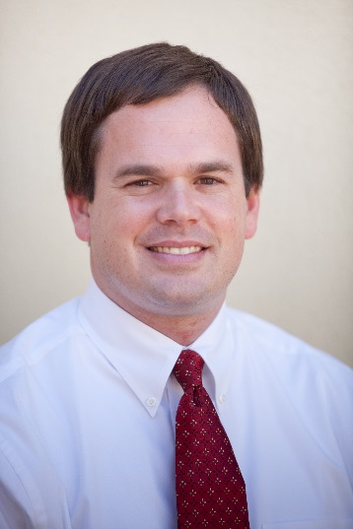
Northwest Regional Representative: Jeffrey Richardson, Curator with the Farmington Museum, has agreed to run for Northwest Regional Representative.
Duties: The Northwest Regional Representative is responsible for representing museum associations and Association members in the northwest region of New Mexico, recruiting new members from their region, organizing at least one regional event per year, and providing written information for the newsletter. The Northwest Region includes: Cibola, McKinley, and San Juan Counties.
Bio: Jeffrey Richardson is the Curator of Exhibits at the Farmington Museum. He worked previously at the Autry Museum of the American West in Los Angeles. Richardson has appeared as an expert commentator on numerous television programs, including Mysteries at the Museum, Pawn Stars, Storage Wars, and History Detectives, and he has written several books and articles, including Colt: The Revolver of the American West and “Cowboys and Robots: The Birth of the Science Fiction Western.” Richardson assumed the office of Northwest Regional Representative midterm and hopes to have the opportunity to be elected to a full term.

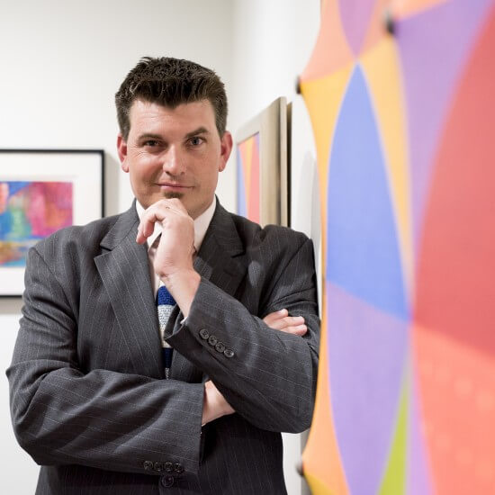
North Central Regional Representative: Ryan Flahive, Archivist with the Institute of American Indian Arts, has agreed to run for North Central Regional Representative
Duties: The North-Central Regional Representative is responsible for representing museum associations and Association members in the north-central region of New Mexico, recruiting new members from their region, organizing at least one regional event per year, and providing written information for the newsletter. The North Central Region includes: Los Alamos, Rio Arriba, Santa Fe, and Taos Counties.
Bio: Ryan Flahive received a BA in history and anthropology at Lindenwood University in St. Charles, Missouri before achieving an MA in History and Museum Studies from the University of Missouri-St. Louis in 2003. Ryan has worked in several museum capacities in Missouri, Wyoming, Arizona, and New Mexico, including a four year stint as Director of Research, Archives, and Publications at Sharlot Hall Museum in Prescott, Arizona. 2017 marks the start of his of his ninth year as archivist at the Institute of American Indian Arts in Santa Fe, New Mexico and teaches courses in archives management and oral history methods while meagerly attempting to manage the unruly mass of paper in the IAIA Archives. Flahive is the editor of two publications, Celebrating Difference: Fifty Years of Contemporary Native Arts at IAIA, 1962-2012 (2012) and The Sound of Drums: A Memoir of Lloyd Kiva New (2016).

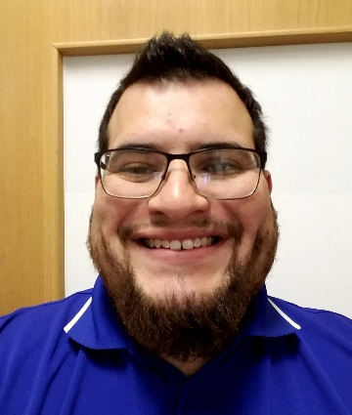
Southeast Regional Representative: Edward VanScotter, Assistant Director with the Carlsbad Museum & Art Center, has agreed to run for Southeast Regional Representative
Duties: The Southeast Regional Representative is responsible for representing museum associations and Association members in the southeast region of New Mexico, recruiting new members from their region, organizing at least one regional event per year, and providing written information for the newsletter. The Southeast Region includes: Chaves, Curry, De Baca, Eddy, Lea, Lincoln, Otero, and Roosevelt Counties.
Bio: Edward VanScotter was born in Oregon and raised in Washington State. After completing a B.A. in interdisciplinary studies with a minor in history at Eastern Washington University, Edward followed his geologist girlfriend (now bride) south to Carlsbad, New Mexico. In the summer of 2014, Edward started working at the Carlsbad Museum & Art Center as a part-time attendant. He was promoted to Curator of Collections in 2015, and in December of 2016 became Museum Assistant Director. In August of 2017, Edward realized he found his calling and enrolled in The University of Oklahoma’s Masters of Arts in Museum Studies program. In the amazing amount of spare time he has, Edward enjoys spending a few minutes a day with his wife and their 10-month- old daughter, reading, playing guitar, and wishing he could be the SE Regional Rep for NMAM.

